**When 2 clients have connected to the server:**

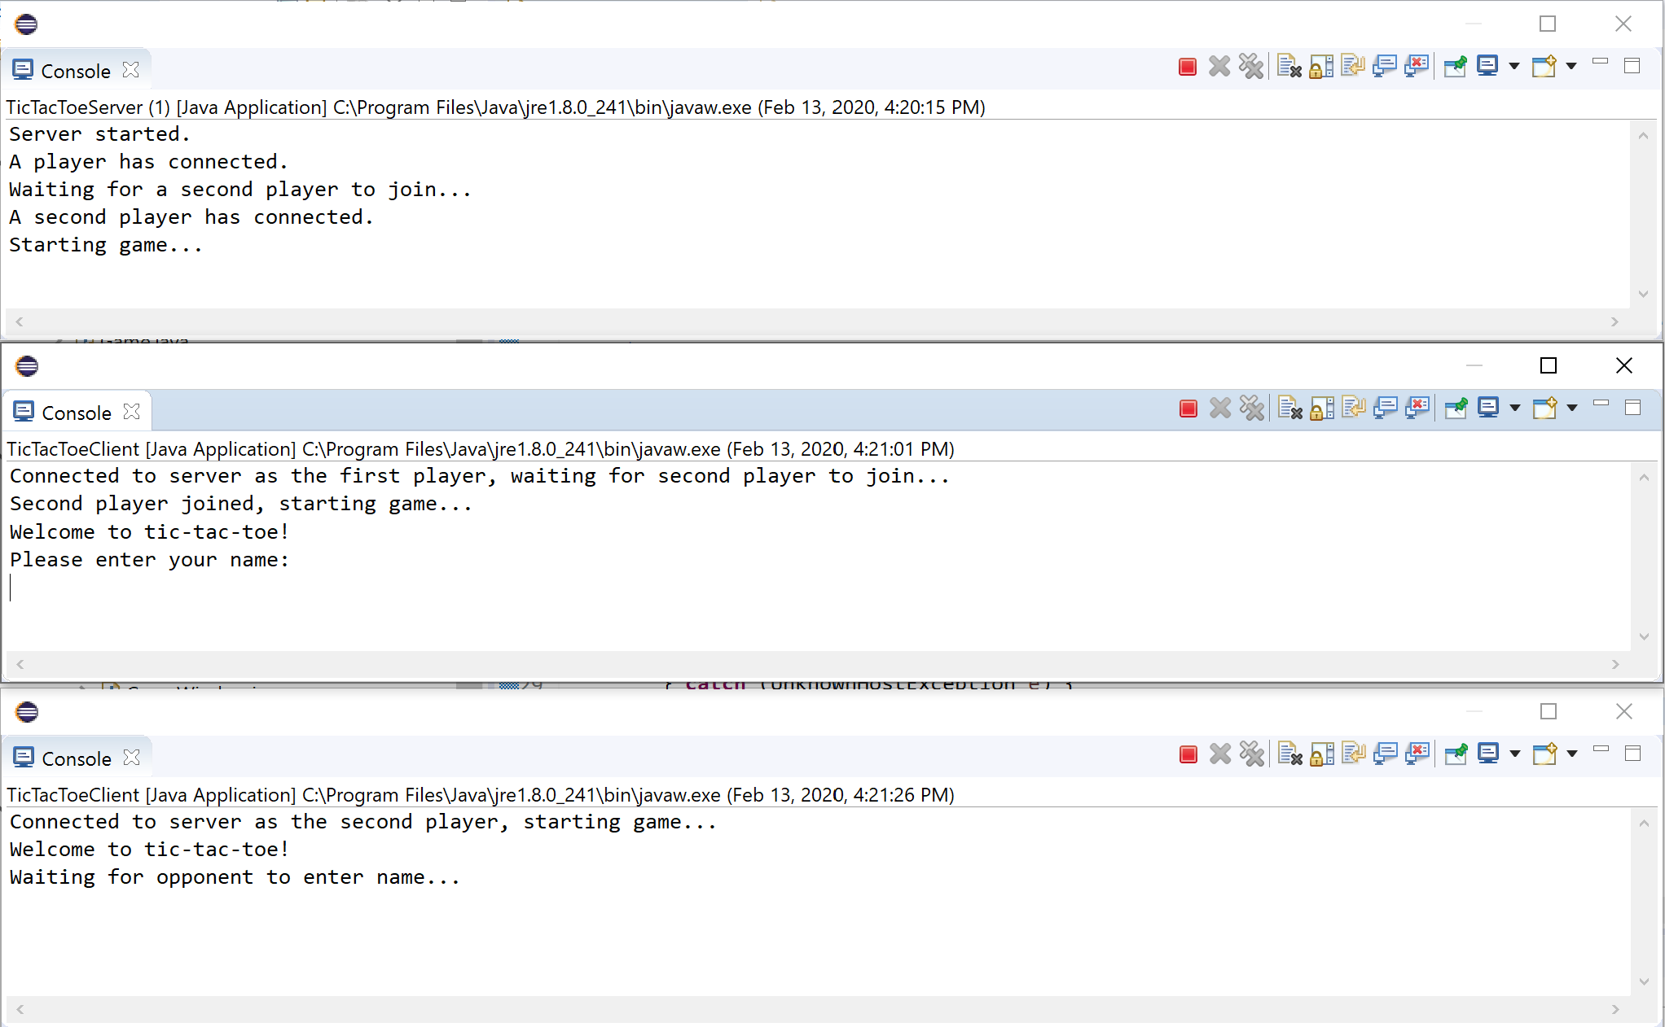

**When both players have entered in their names:**

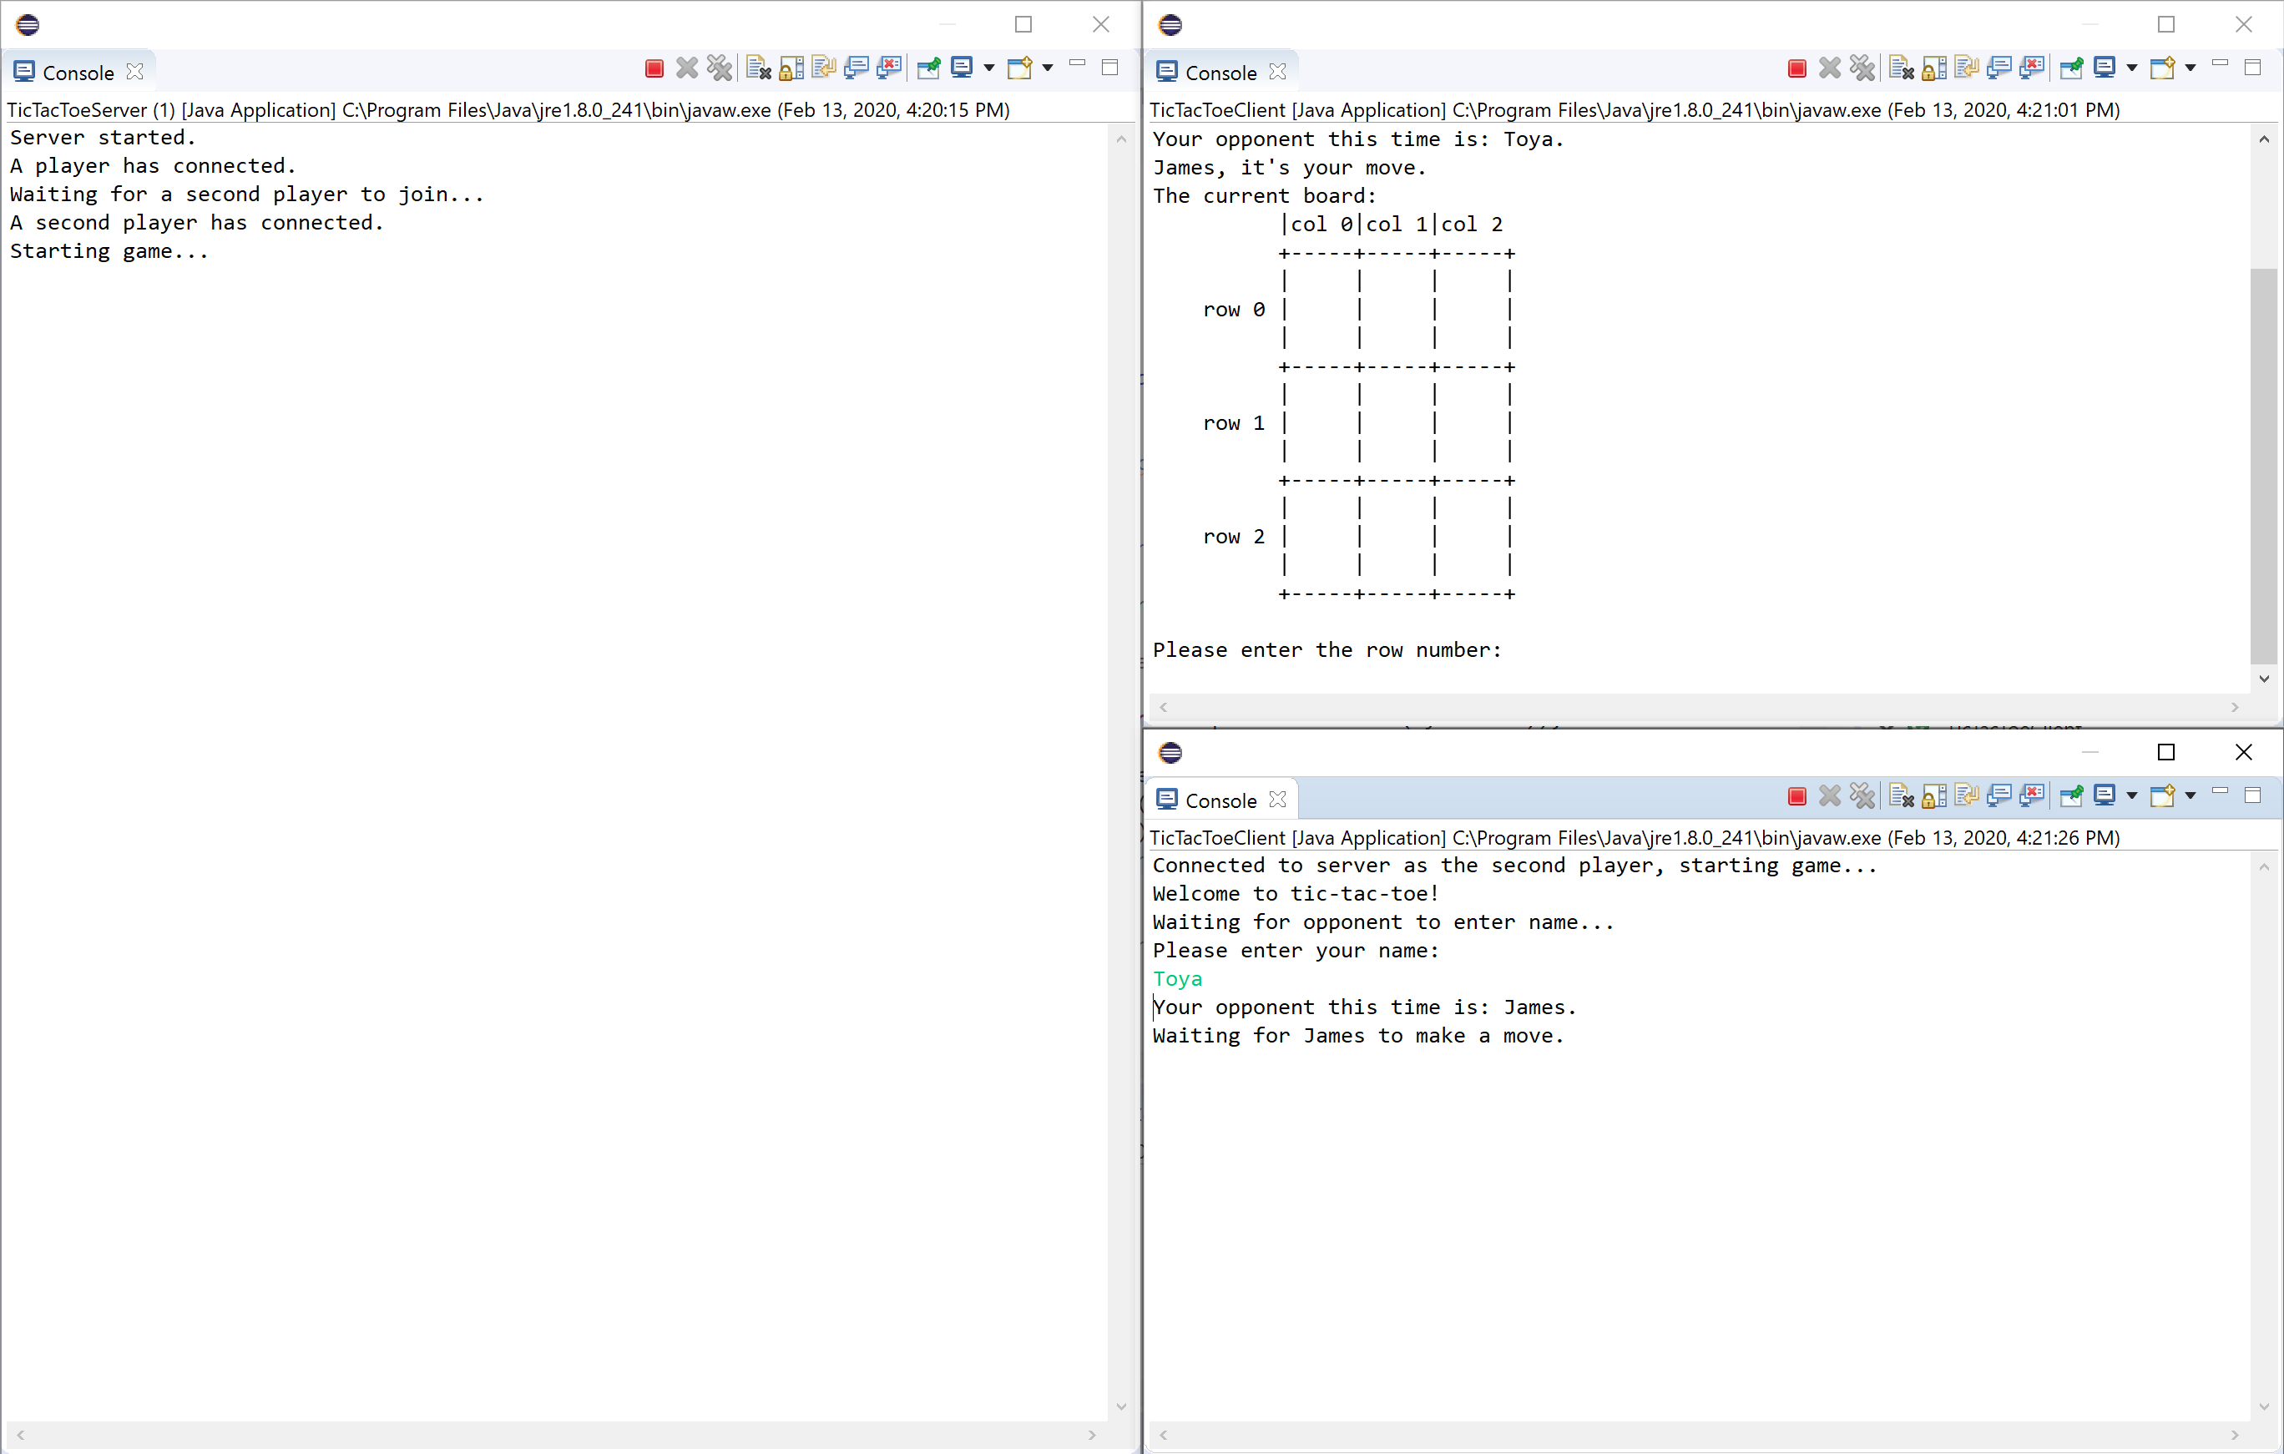

**Game ending screen (client applications have closed, but the server keeps running):**

